EyeSpyJustify
Section 1: Methodology – Technical details of additional analysis.
For this Milestone, we maintain our original pipeline of predicting using deep learning to diagnostic analysis with large language models. In each section, we made major adjustments to improve accuracy.

1.1: Deep Learning Predictions
We restructured our deep learning process by switching from an equal weight ensemble of the three CNNs, EfficientNet-B0, ResNet18, ShuffleNet-V2, to a fusion architecture. The fusion model we designed has three main components: (1) feature extraction from the three CNNs, (2) transformer to weigh feature importance, and (3) neural network multi-label prediction block. Instead of using the CNNs directly for predictions, we extracted features from the final layer before each model’s classifier layer and applied them on the train, validation, and test datasets. The resulting sizes of the feature vectors were [batch size, number of nodes in final non-classifier layer of the CNN], specifically [B, 1024] from ShuffleNet, [B, 1280] from EfficientNet, and [B, 2048] from ResNet.

1.1.1: Data Preprocessing
To help with generalization, we applied various data augmentation techniques, including horizontal and vertical flips, color jitter, and gaussian blur. Additional augmentation was applied to the smaller classes with less than 100 images.

In the current model, we combined several diseases that are either different severities with the same underlying conditions or were subgroups of similar disease. These diseases include: Central Serous Retinopathy and Central Serous Chorioretinopathy, Optic Disc Edema and Disc Edema, Hypertension and Hyptertensive Retinopathy, Retinitis + Chorioretinitis. We also reduced some of the dataset to minimize the overrepresentation of some classes.

To further address class imbalance, we utilized multi-label stratification shuffle split to ensure that the proportion of each class was the same across the train, validation, and test sets. This is to ensure that smaller classes appear as frequently in the train test as they do in the validation and test.

1.1.2: Transformer
The goal of feature extraction and the transformer is to build a fused representation of each image. Each of the CNN feature vectors were projected to a common embedding size of [batch size, 512] then normalized before converted to tokens. By stacking the converted tokens to size [batch size, 3, 512], the feature vectors could then be passed to the transformer for the attention-based fusion.

At the start of the transformer, we defined the encoder layer to have a dropout of 0.1 and ReLu activation function. Within the transformer, we defined a multi-layer perceptron which outputs one attention score per token to determine which CNN is more effective at identifying the eye disease for each specific image case. Then by using softmax to convert the attention scores to weights, the weights are applied to the tokens to form a weighted sum fusion function.

1.1.3: Prediction Block
The prediction block is defined with the following architecture:
Each training and validation epoch trains and evaluates the transformer and prediction block together. The prediction block is designed with the architecture as shown in Figure 1.

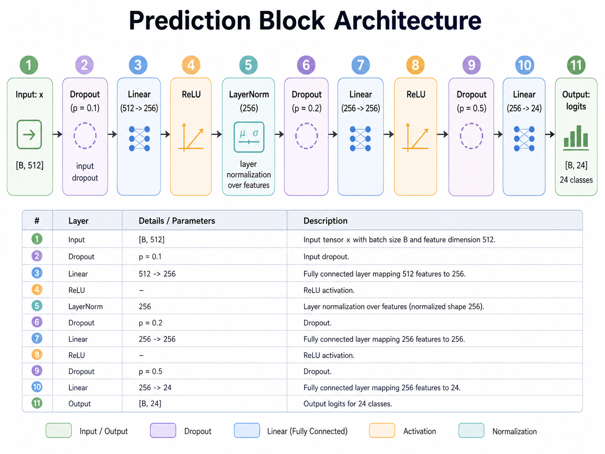
Figure 1

We set the dropout rate, number of hidden layers, and number of nodes per hidden layer by following standards of existing literature on retinal disease fusion classifiers. The dropout layers were included to improve model generalization, which is especially important for retinal disease classification due to the reliance on details to identify the diseases. We chose the ReLU activation function to improve computational efficiency and to prevent vanishing gradient problems.

For the loss function, we selected BCE with Logits Loss, which combines a Sigmoid activation layer and the BCE loss into a single class. We chose to use this loss function to support our multi-label deep learning framework and for consistency with our CNNs, which also use BCE with Logits Loss. For the optimizer, we selected AdamW to improve generalization.

We set the learning rate to be 1e-4 and weight decay to be 1e-4. Due to compute limitations, we were unable to tune these two hyperparameters. With improved compute resources, we would test a wider range of hyperparameters to optimize model results.

The output of the prediction block are logits for each class, which is then passed through a sigmoid function to obtain probabilities for each class individually. After evaluating the model with a range of thresholds [0.3, 0.4, 0.5, 0.6, 0.7], we observed that 0.5 led to the highest micro F1, and so we utilized 0.5 as the prediction block’s threshold. Therefore, if the probability for a class is greater than 0.5, it would be predicted as a label for the retinal image.

1.2: MedGemma-based ReAct Agent
Through a comparison of RAG-based results versus MedGemma diagnostic analysis, we observed that MedGemma performed significantly better, with well-structured sentences and better disease similarity comparisons. Therefore, we decided to focus on using MedGemma and improved the diagnostic support function by building a ReAct agent for specific diagnostic purposes. The ReAct agent pipeline is built as follows: (1) predictions and GradCam images produced by each CNN are sent to the agent, (2) the agent calls tools to support disease explanations and recommendations, (3) the chain of thought is sent to the frontend.

We built three primary tools. The first is a comparison tool that performs similarity analysis between the identified diseases and analyzes common reasons why they may co-occur or get confused for one another. The second is a GradCam analysis tool that examines regions of the retinal image that each CNN focuses on and flags important features for further analysis. The third is a next steps recommendation tool to provide suggestions to doctors and patients for areas that need further testing or treatment.

After testing, we found that MedGemma isn’t a good model to use as a ReAct agent. We decided to shift towards using GPT-4.1.nano as the orchestrator of our tool use pipeline. We instead use MedGemma within our tools to give good medical reasoning. Additionally, we decided to use LangGraph as the engine to our workflow. It is used to execute tools, keep track of previous tool use outputs within an AgentState, and orchestrate where the output of the tools should go.

Section 2: Results – Succinct summary of findings.
.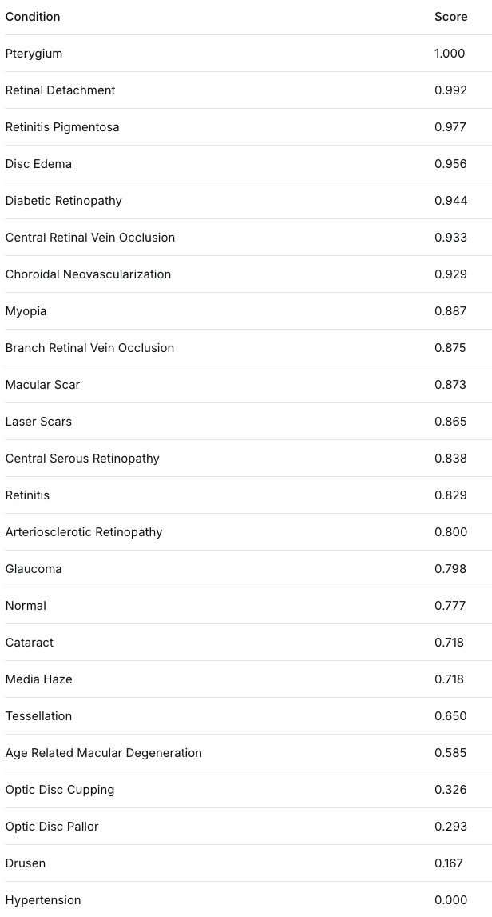   

It is worth noting that the previous F1 score for NORMAL, was much higher in the original model. As it is the class with the highest number of samples, the model was predicting Normal for the highest accuracy. This lower F1 score indicates that the model is no longer predicting Normal simply because it is the majority class. Some of the classes such as Optic Disc Cupping, Optic Disc Pallor, Drusen, and Hypertension have very low F1 scores, this can be attributed to the threshold levels or the data augmentation rendering the classification of these images to be impossible. For example hypertension is identified from details in the blood vessels of the eye, which may not be visible after applying gaussian blur.

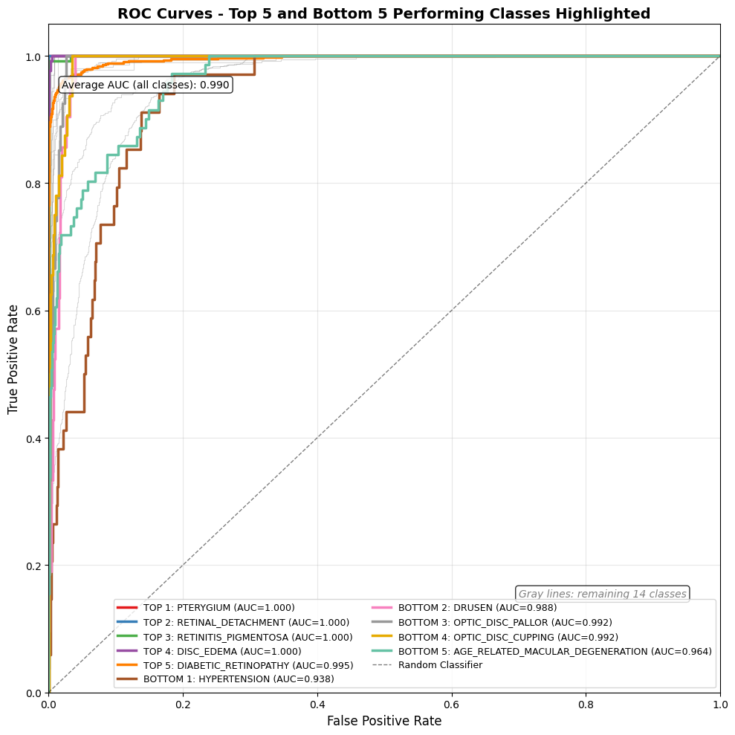
Each of the diseases has a high AUC, indicating that the model is very reliable in separating classes. However this is in contrast to the F1 scores we mentioned earlier. Combined, this indicates that the default threshold (0.5) may not be appropriate for the underperforming classes. Given the model’s strength in identifying true positives and relatively low false positive rate, this points to false negatives being a primary contributor to poor performance for classes with lower F1 scores.

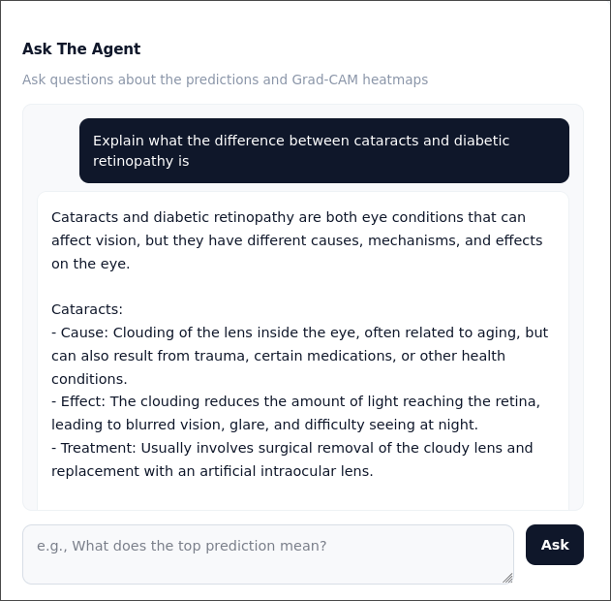
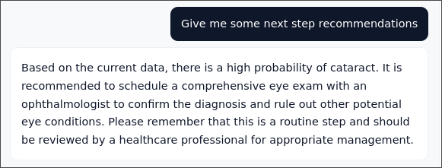
We found that our ReAct agent pipeline was very effective in producing relevant clear responses. Using MedGemma as a specialized “expert” in the tools worked well since it was trained on medical knowledge. The model also followed our safety rules, always stating that the model was not one that should be used for medical diagnosis and that all knowledge should be reviewed by a medical professional. The responses were also very concise and easily understandable.

Section 3: Conclusions – Strengths, weaknesses, limitations, future work directions.

Strengths: On top of existing literature, we have explored additional methodologies to improve large-scale multi-label classification and a diagnostic pipeline. First, existing literature primarily focused on few eye disease classifications, but our pipeline supports more classes than the current largest number of 20. Our pipeline supports a total of 24 classes, with 84% of labels successfully classified at a rate significantly higher than random guessing. Second, in-depth treatment of class imbalance using multiple augmentations to extrapolate smaller classes and stratification in train, validation, and test splits. Third, the transformer-supported fusion model adds to existing literature, which primarily uses concatenation of CNN features. The attention score enhances the model’s ability to identify specific diseases, taking advantage of the strengths of each CNN. Fourth, our addition of a diagnostic agent provides support to doctors, connecting classification of eye diseases with insight to reasons on classification.

Weaknesses and Limitations: Our pipeline has a few limitations. First, our current model does not differentiate between different stages of a disease, or severity, future work can add upon subgroup differentiation. For conditions such as hypertension and drusen, which are identified by looking at faint patterns in the blood vessels and small yellow deposits in the eyes, with gaussian blur, it may make it more difficult to identify them and needs different data preprocessing steps. Second, some classes still perform poorly despite large amounts of augmentation on the dataset and handling of class imbalance. This is likely due to lack of data and need for additional tuning to better identify their specific thresholds. Third, as mentioned, thresholds are currently set at 0.5 across the board, from all CNNs to the prediction block. Optimal thresholds might differ by class.

Future Work Directions: Due to computational limitations, we weren’t able to test a variety of hyperparameters and thresholds. Ideally we tune the hyperparameters on a model basis and the threshold on a disease basis. Future works can further tune hyperparameters. Additional datasets would also be needed to improve classification generalization for smaller classes.

Section 4: Workflow – Timeline of tasks + each member’s contributions
All three members frequently met together to brainstorm, research, and discuss architecture improvements. This is our Git repository. Please note that Git commit history does not accurately portray member contributions as we worked collaboratively through Google Colab.

Emily: ShuffleNet training and testing, ShuffleNet feature extraction, transformer and prediction block code, MedGemma comparison tool and recommendation tool
Joe: EfficientNet training and testing, EfficientNet feature extraction, MedGemma framework code, connecting fusion model to MedGemma, backend development
Si Yue: ResNet training and testing, ResNet feature extraction, MedGemma GradCam tool, frontend development

Timeline
4/5-4/11: Further research on pipeline architecture and redesigning, data preprocessing and augmentation, class imbalance treatments
4/12-4/18: Individual CNN model training and testing
4/19-4/25: Building transformer, prediction block, and MedGemma
4/26-5/3: Refining pipeline, writing report, and preparing presentation
5/3-5/10: Refining report and practicing presentation

